ASSIGNMENT 2

Name : Urvashi Rathore

SAP ID : 500083262

1. Create a Dockerfile

**Command** : mkdir imga2

touch DockerFile

vim DockerFile

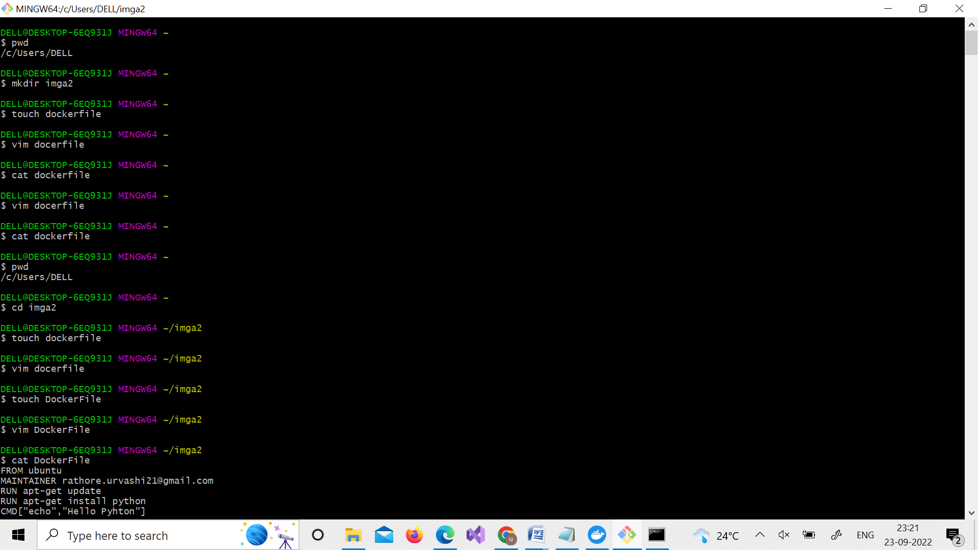

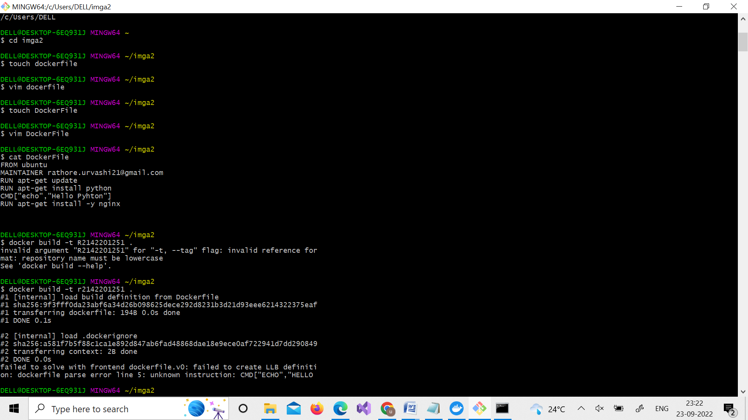

1. Pull an Ubuntu image in it.

**Command**: FROM ubuntu

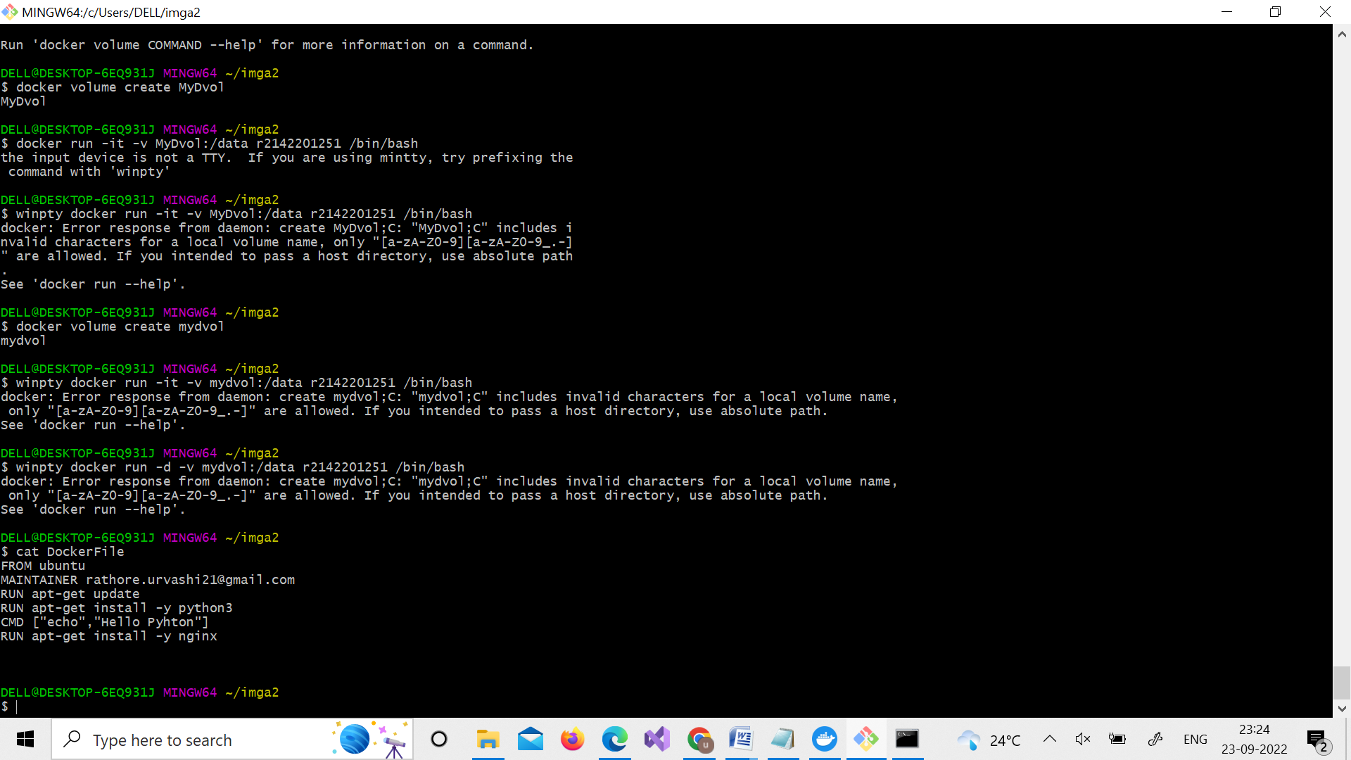

3.Install python in it.

**Command** : MAINTAINER [rathore.uvashi21@gmail.com](mailto:rathore.uvashi21@gmail.com)

RUN apt-get update

RUN apt-get install –y pythone3



4.Echo a message “Hello Python”

**Command** : CMD [“echo”,”Hello Python”]



5.Install Nginx server in it

**Command** : RUN apt-get install –y nginx



6.Build an image of this Dockerfile named as “your roll number”

**Command**: docker build –t r2142201251

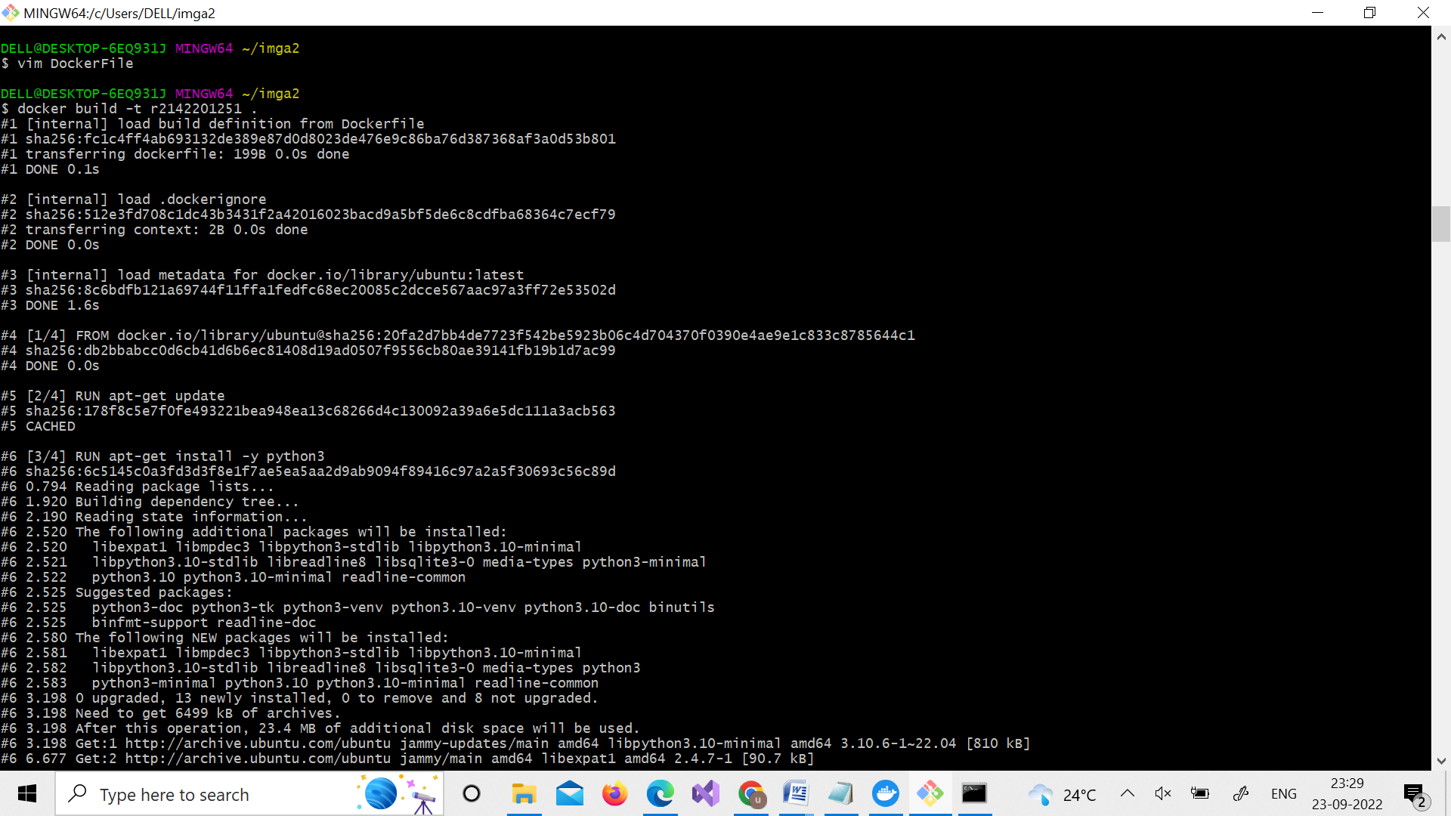

7.Push that image on Docker Hub

**Command**: docker login docker images

docker tag IMG_ID urvashirathoree/r2142201251

docker push urvashirathoree/r2142201251

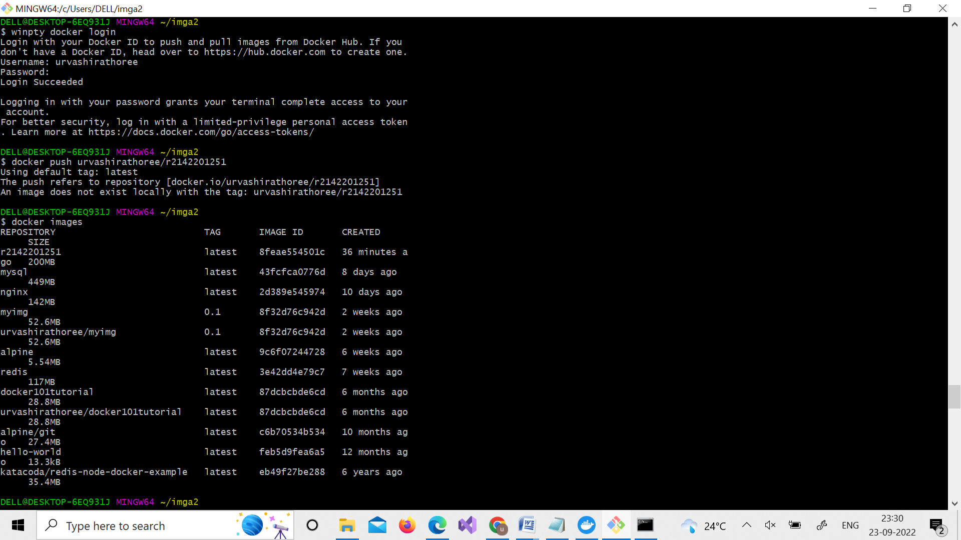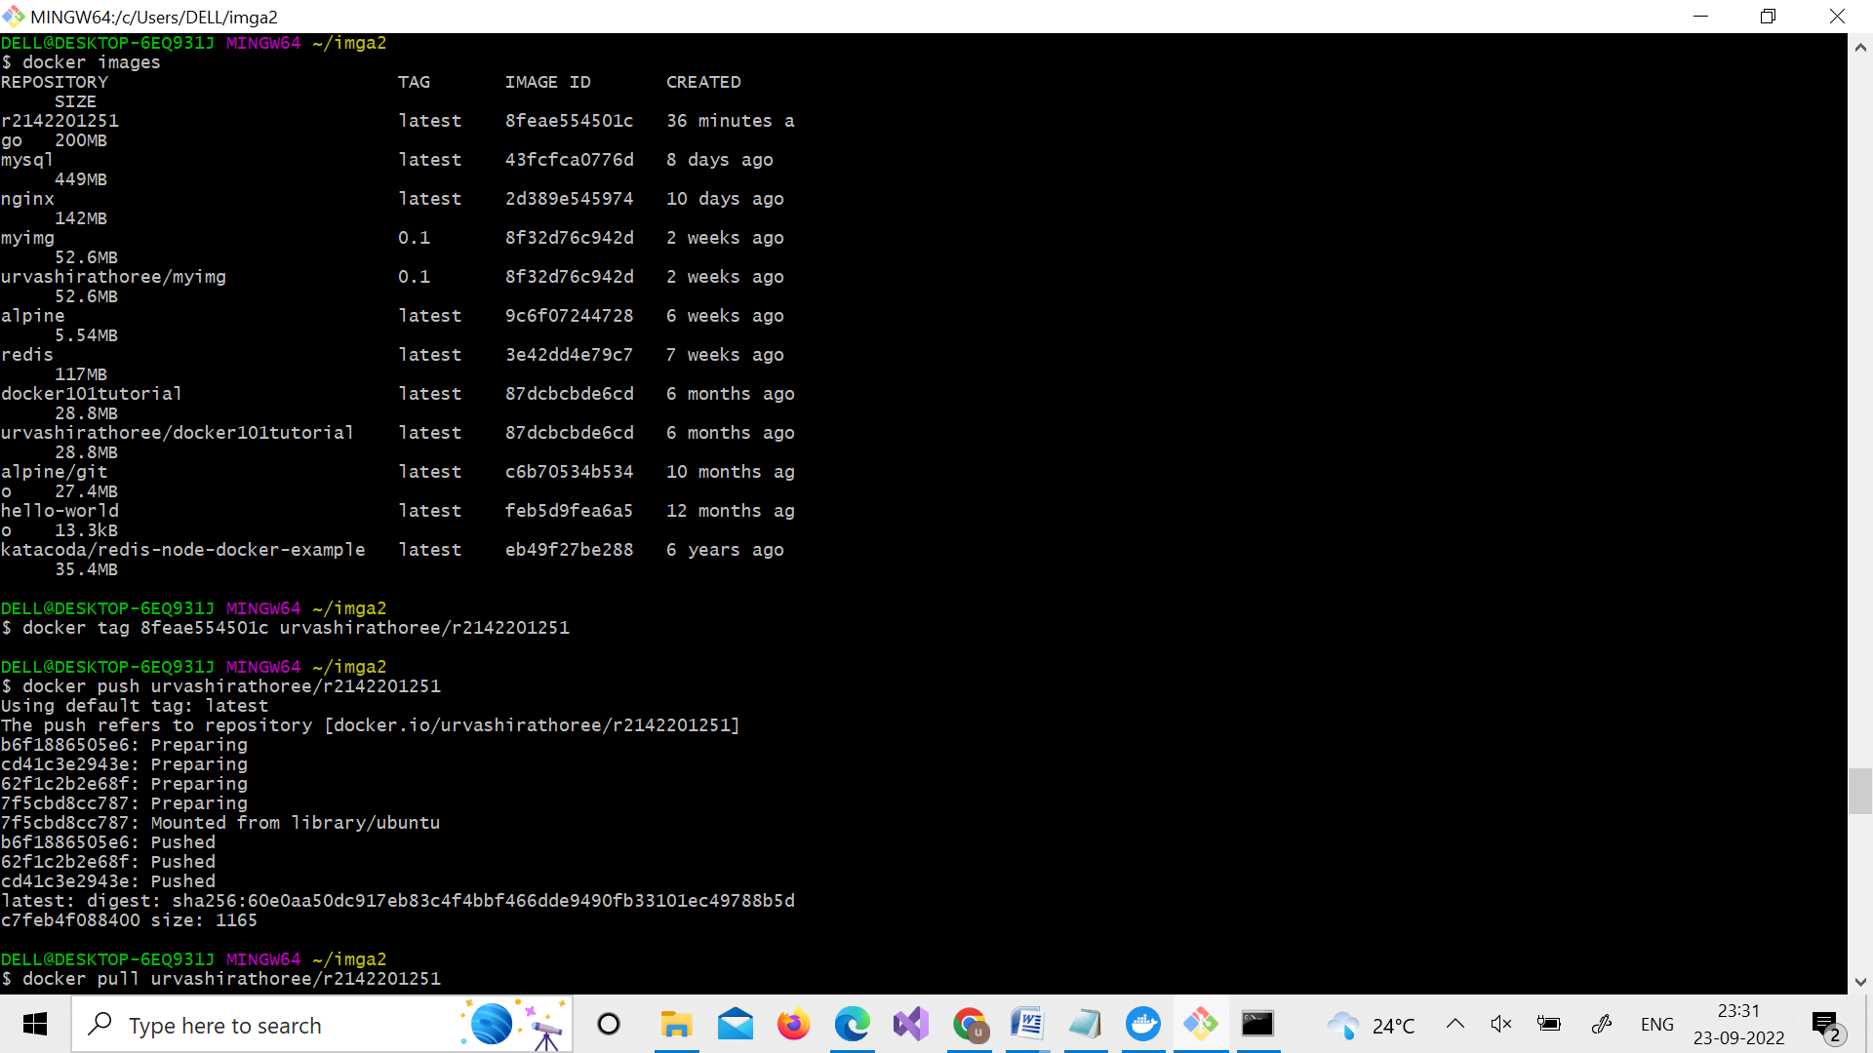

8.Pull that image from Docker Hub

**Command** :docker pull urvashirathoree/r2142201251

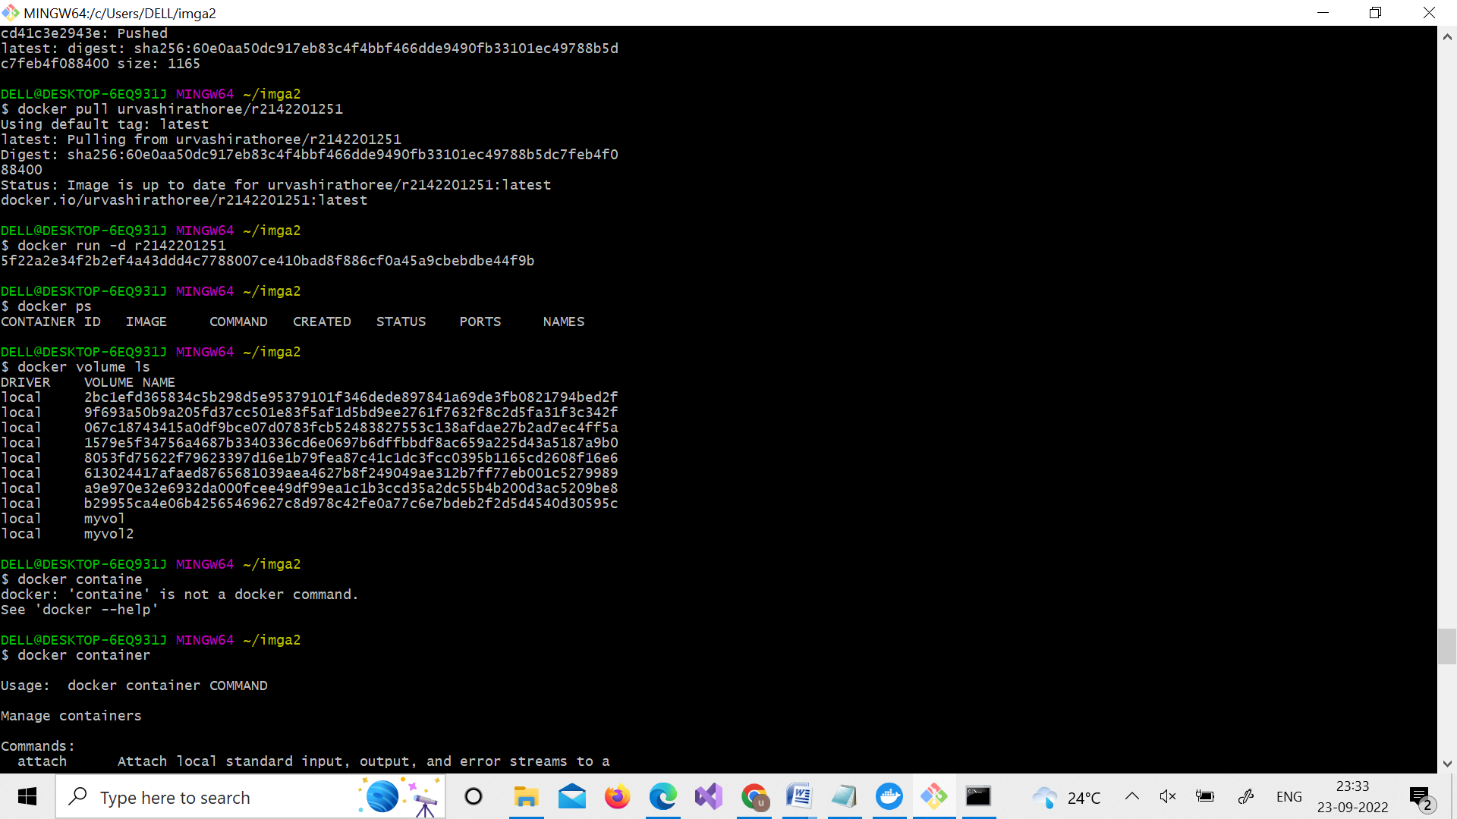

9.Run a container from this image

**Command** : docker run –d r2142201251



10. Create volume MyDvol for this container.

**Command**: docker volume create MyDvol

docker volume ls

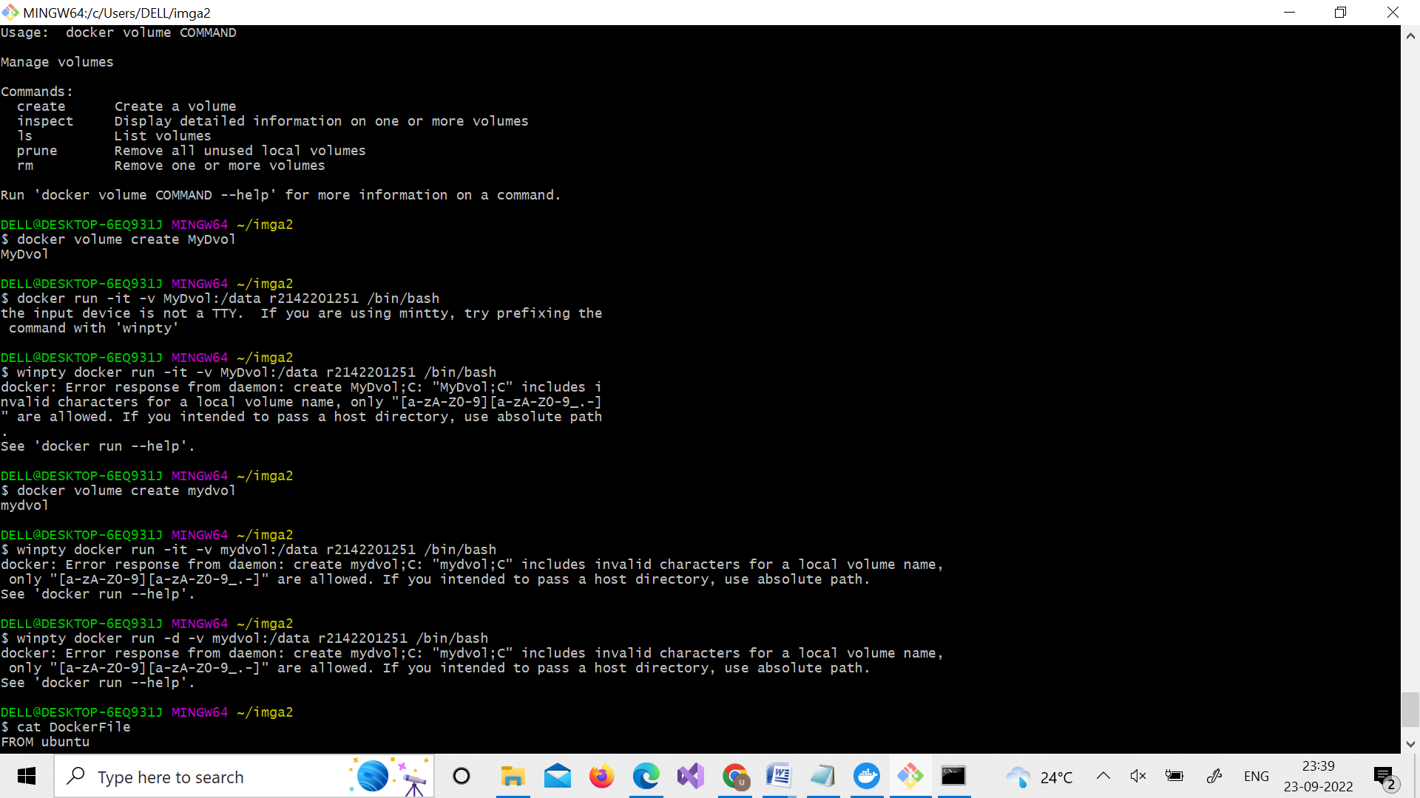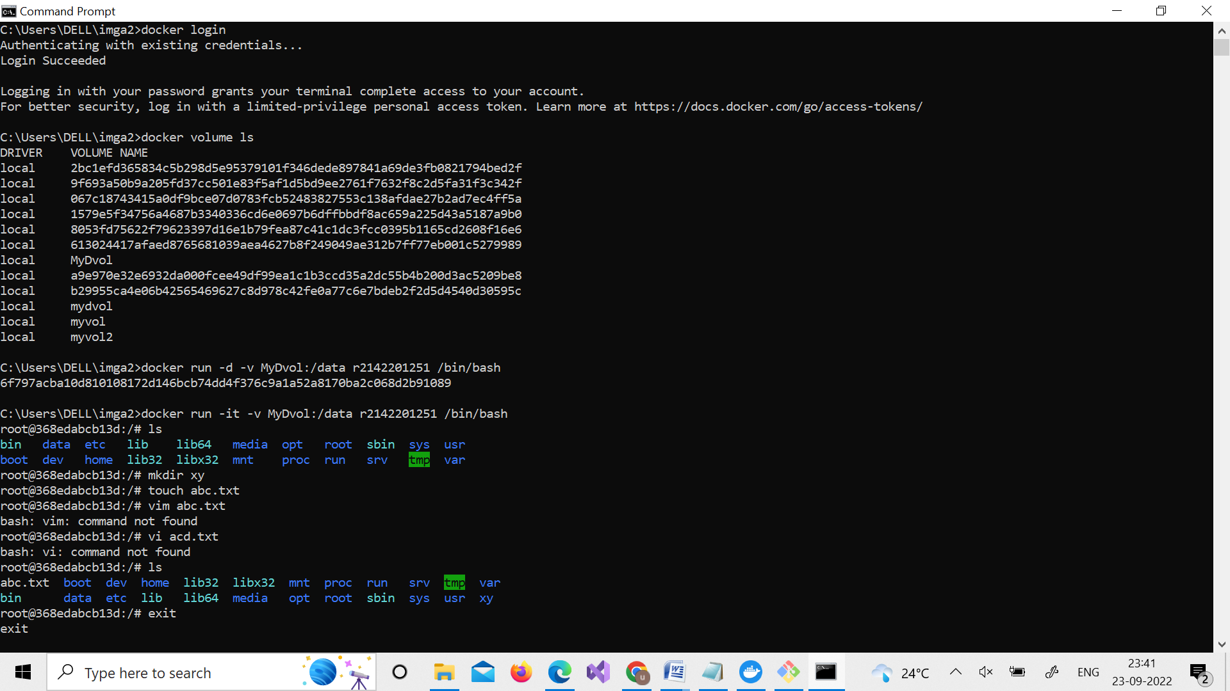

11. Create a file in this volume with a text message “Hello MyDvol”

**Command**: docker run –it –v MyDvol :/ data r2142201251 /bin/bash

#ls #touch abc.txt #ls #exit

